  - Cron Jobs:
- Purpose: Cron is a built-in scheduling tool found in Unix-like systems (Linux, macOS) that automates task execution at specific times or intervals. This is essential for data engineering tasks that must run regularly, like data pipelines, ETL processes, and scheduled reports.
- Format: Cron expressions define the schedule using five fields: minute (0-59), hour (0-23), day of month (1-31), month (1-12), and day of week (0-7, where 0 or 7 is Sunday).
- Capabilities: Cron is ideal for simple schedules, but it has limitations:
  - Not well-suited for complex dependencies or workflows.
  - Only runs on the machine where it's configured.
  - Lacks monitoring, logging, and error handling.

APACHE AIRFLOW:Streamlining Data Pipelines and Workflows
Introduction
Apache Airflow is an open-source platform for developing, scheduling, and monitoring batch-oriented workflows and coordinating different tasks to run in the right order and automate the data pipelines.
Airflow helps to:
- Automate complex data pipelines.
- Schedule tasks to run at specific times.
- Handle dependencies between tasks.
- Monitor and manage your workflows.

Architecture:

- Airflow is a platform that lets you build and run workflow. A workflow is represented as aDAG(a Directed Acyclic Graph), and contains individual pieces of work called Tasks, arranged with dependencies.
- A DAG specifies the dependencies between tasks, which defines the order in which to execute the tasks. Tasks describe what to do, be it fetching data, running analysis, triggering other systems, or more.
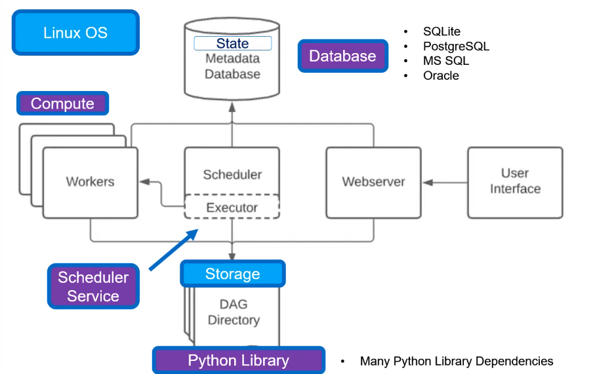
Key components:
- DAGs:Define your workflow steps and dependencies,with steps like "download data," "clean data," "analyze data," and "send results."
- WebServer:Monitor workflow progress, see logs, and manage DAGs.
- Scheduler:Reads DAGs, plans workflow execution, and triggers tasks at scheduled times.Executors assigns tasks to workers.
- Tasks:Each step is a task, and Airflow knows which tasks depend on others (dependencies).Individual steps in the workflow with specific actions
- Operators:workers run the tasks using Python code or other operators. Built-in or custom tools to perform specific tasks.
- MetaData Database:A MetaData Database which airflow components use to store state of workflows and tasks.
Worker, which executes the tasks given to it by the scheduler.Triggerer, which executes deferred tasks.Dag processor, which parses DAG files and serializes them into the metadata database.Folder of plugins,Plugins are a way to extend Airflow’s functionality.

Workloads:

A DAG runs through a series of Tasks, and there are three common types of task

Operators, predefined tasks that you can string together quickly to build most parts of your DAGs.

Sensors,They act as checkpoints, waiting for a specific condition to be met before allowing downstream tasks to proceed.

TaskFlow:
- A TaskFlow is a powerful and elegant way to define your DAGs using Python functions instead of the traditional operator-based approach. Even helpful in reusing decorated tasks and can be used from another file(importing the function).
- The data pipeline chosen here is a simple pattern with three separate Extract, Transform, and Load tasks.

Control Flow:
DAGs are designed to be run many times, and multiple time parallely. DAGs are parameterized, always including an interval they are “running for”.Tasks have dependencies declared on each other.DAG either using the >> and << operators:
eg: first_task >> [second_task, third_task]

fourth_task << third_task or

can be used with set_upstream and set_downstream methods.

To pass data between tasks you have three options:

- Xcoms (“Cross-communications”), a system which have tasks push to and pull from metadata.
- Uploading and downloading large files from a storage service.it can be local or cloud.
- TaskFlow API automatically passes data between tasks.

Task LifeCycle:
In Total there are 11 different kinds of stages,

No_status-----scheduler-------------Executor
| |
scheduled Queued
| |
removed Worker
| |
Up stream failed Running------success
| |--------Failed--------(retry)
skipped |--------Shutdown---(retry)

DAGs:

- A DAG (Directed Acyclic Graph) is the core concept of Airflow, collecting Task together, organized with dependencies and relationships to say how they should run.
- The DAG itself doesn’t care about what is happening inside the tasks; it is merely concerned with how to execute them - the order to run them in, how many times to retry them, if they have timeouts, and so on.
There are three ways to declare a DAG,
1.with Context manager.
2.Dag into any opterator.
3.With @dag decorator

Task Dependencies:
- A Task/Operator it has dependencies on other tasks and other tasks depend on it Declaring these dependencies between tasks is what makes up the DAG structure (the edges of the directed acyclic graph).upstream—downstream.
- declaring more complex dependencies.like if two list of task depends on all parts of task. Eg: cross.downstream([t1,t2],[t3,t4]).
- If we need to can one task excute next by next.chain function can be made. Eg: chain(t1,t2,t3,t4).

Running DAGs:
- When they are triggered either manually or with APIs.
- On a defined schedule, which is defined as part of the DAG.
Every time when DAG runs, it is called creating a new instance of that DAG which Airflow calls a DAG Run. DAG Runs can run in parallel for the same DAG, and each has a defined data interval, which identifies the period of data the tasks should operate on.

Default Arguments:
Omany Operators inside a DAG need the same set of default arguments (example like retries). To create individually every time for every operator.just can pass default_args and reuse it.

Branching

You can make use of branching in order to tell the DAG notto run all dependent tasks, but instead to pick and choose one or more paths to go down. This is where the @task.branch decorator come in.
There are situations, though, where you don’t want to let some (or all) parts of a DAG run for a previous date; in this case, you can use the LatestOnlyOperator.

Cron Presets
You may set your DAG to run on a simple schedule by setting its schedule argument to either a cron expression,
CatchUp
The scheduler, by default, will kick off a DAG Run for any data interval that has not been run since the last data interval (or has been cleared). This concept is called Catchup.

Backfill
There can be the case when you may want to run the DAG for a specified historical period.

Operators

An Operator is conceptually a template for a predefined Task, that you can just define declaratively inside your DAG.
BashOperator - executes a bash command
PythonOperator-calls an arbitrary Python function
EmailOperator -sends email
Jinja Templating-Used to will fill in variables at runtime. Syntactically, variables inserted at runtime are denoted in your code with double curly braces.
Sensors
Instead of blindly jumping to the next task, the sensor waits for specific conditions to be met before allowing the process to continue.
- Defined conditions: Each sensor checks for a specific condition, like a file existing, a data pipeline completing, or a certain time of day.
- Regular checks: they actively check for the condition at regular intervals
- Success and failure: Once the condition is met,the sensor succeeds and allows the next task to run. If not, it keeps waiting and retries after a while.

Different types:
- FileSensor: Waits for a specific file to appear.
- TimeSensor: Waits until a specific time of day or duration has passed.
- ExternalTaskSensor: Waits for a task in another DAG to finish.

Executors:
- Receive tasks from the scheduler.
- Assign each task to a worker.
- Monitor the execution of the tasks.
- Report the results back to the scheduler.
Types of executors:
- Local Executor: Like a single executor processing everything themselves, suitable for small setups or testing.
- Sequential Executor: Like each , one at a time, good for simple workloads.
- Parallel Executor: Like multiple executors working simultaneously, best for workloads that can be split into parallel tasks.
- Remote Executors: Like having executors in different Systems (worker machines),ideal for scaling your workflows across multiple machines.
- Debug Executor:The DebugExecutor is meant as a debug tool and can be used from IDE.

Xcom
XComs (short for “cross-communications”) are a mechanism that let tasks talk to each other, as by default Tasks are entirely isolated and may be running on entirely different machines.
An XCom is identified by a key (essentially its name), as well as the task_id and dag_id it came from. They can have any (serializable) value, but they are only designed for small amounts of data; do not use them to pass around large values, like dataframes.
XComs are explicitly “pushed” and “pulled” to/from their storage using the xcom_push and com_pull methods on Task Instances.
Airflow Pool:
- Airflow pools can be used to limit the execution parallelism on arbitrary sets of tasks.
- The list of pools is managed in the UI (Menu - Admin - Pools) by giving the pools a name and assigning it a number of worker slots.
Pools:Tasks are assigned to pools, which define the slot limit. The default pool (default_pool) has 128 slots by default. You can create custom pools with different slot limits.
- Resource control: Each task consumes one slot by default, but you can use the pool_slots argument to configure tasks to occupy more slots, depending on their resource requirements.
- Queueing: When all slots in a pool are filled, runnable tasks get queued and wait for a slot to free up. The queuing order is usually based on priority weights assigned to tasks or pools.
Benefits of using slots:
- Prevent resource overload: Avoid overwhelming workers with too many tasks, ensuring smooth execution and efficient resource utilization.
- Prioritize critical tasks: Assign higher slot limits to high-priority tasks, ensuring they get executed sooner, even with limited resources.
- Manage resource allocation: Create pools with different slot limits to allocate resources based on specific task types or needs.
- in a pool are filled, runnable tasks get queued and wait for a slot to free up. The queuing order is usually based on priority weights assigned to tasks or pools.
Deferred tasks in Airflow are a relatively new feature introduced in version 2.2, offering a way to improve resource utilization and efficiency in your workflows. Imagine you have a task waiting for an external event but that event might take a while. Instead of constantly checking and using a worker slot, the task can defer itself and release the slot.
- Task triggers: You use special deferrable operators (like DeferrableBashOperator) to define tasks that can be deferred. These operators typically contain trigger logic.
- Deferring execution: Instead of immediately executing, the operator calls self.defer(), releasing the worker slot and submitting a trigger to a separate service called the triggerer.
- Trigger monitoring: The triggerer constantly monitors triggers and wakes up deferred tasks when their conditions are met (e.g., the API call returns).
- Resuming execution: Once awakened, the deferred task gets a worker slot and resumes its execution from the point where it was deferred.

Understanding Use Cases: cron is still useful managing complex data pipelines, especially when:
  - Dependencies exist between tasks (e.g., one task's output feeds into another).
  - Workflows need to scale to multiple machines or platforms.
  - Monitoring, logging, and alerting are crucial.
- Demonstration: Build a simple DAG in Airflow that fetches data from an API, processes it, and stores the results.
- Real-World Examples: Share specific cases where Airflow is used in industry (e.g.daily analytics reports, fraud detection pipelines, marketing automation).

Future Exploration: into advanced Airflow concepts like:
  - Triggering DAGs manually or from external sources.
  - Implementing different execution environments (e.g.,Docker).
  - Building a robust Airflow deployment on platforms like Kubernetes.
cron jobs and Airflow serve similar purposes - automating task execution - they have distinct roles and integration possibilities. Here's a breakdown of how cron jobs can interact with and assist Airflow:
Triggering Airflow DAGs:
- Simple Scheduling: Although Airflow has powerful scheduling capabilities, cron jobs can still be useful for initiating Airflow DAGs at specific times or intervals. For example, if you have a cron job running at midnight, it can trigger an Airflow DAG that performs daily data processing tasks.
- Manual Intervention: Cron jobs can be used to trigger Airflow DAGs on demand, enabling manual control for ad-hoc processing or testing purposes.This is helpful for situations where you need specific data for immediate analysis.
Complementing Airflow's Scheduling:
- Fallback Option: For simple schedules, cron jobs offer a lightweight alternative to defining them within Airflow. This can be beneficial if you have numerous straightforward schedules or want to minimize Airflow's workload.
- Hybrid Approach: You can combine both cron and Airflow for scheduling flexibility. Cron jobs can trigger DAGs, and Airflow can handle complex dependencies and execution within those DAGs.
Limitations to Consider:
- Limited Functionality: Cron jobs are not well-suited for managing dependencies, monitoring, or complex workflows. For such tasks, Airflow is the more suitable tool.
- Single Machine Dependency: Cron jobs run on the machine where they're configured,while Airflow allows distributed execution.
Key Takeaways:
- Cron jobs and Airflow are complementary tools,.
- Cron jobs can trigger Airflow DAGs as part of a larger workflow.
- Airflow offers superior scheduling control, workflow management, and monitoring capabilities.

Best Practices:

Creating a new DAG is a three-step process:

- writing Python code to create a DAG object,
- testing if the code meets your expectations,
- configuring environment dependencies to run your DAG.

Creating a task
You should treat tasks in Airflow equivalent to transactions in a database. This implies that you should never produce incomplete results from your tasks.

Deleting a task

Be careful when deleting a task from a DAG. You would not be able to see the Task in Graph View, Grid View, etc making it difficult to check the logs of that Task from the Webserver. If that is not desired, please create a new DAG.

